**Discovering the trends of car sales in Saudi Arabia**

Riyadh is the capital of Kingdom of Saudi Arabia. The population of Riyadh is nearly 5 million and transportation relies mainly on cars. The motivation of this post is to explore the trends of car sale market in Riyadh.

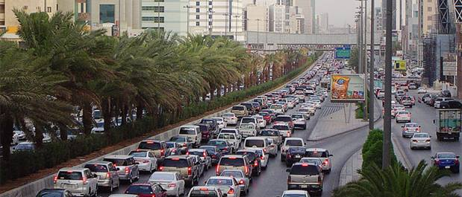

Main Highway in Riyadh [[Source](https://www.royalhaskoningdhv.com/en-gb/news-room/news/20120706pr-major-contract-traffic-problems-riyadh-saudi-arabia/1604)]

My intention is to answer the following questions:

1. What is the most poplar car maker in city Al Riyadh?
2. What is the average car price?
3. If the car bought used, what is the average kilometers that the car has been driven?

**Question 1: What is the most poplar car maker in city Al Riyadh?** 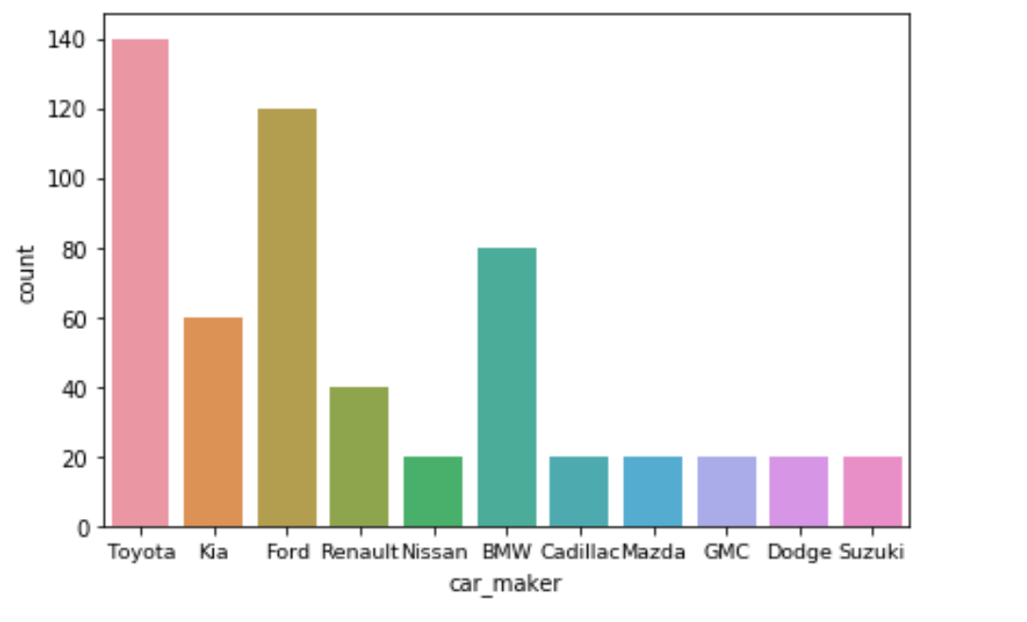

The above Bar Chart analysis shows that the top 3 car brands are; Toyota, Kia and Ford respectively. The giants Japanese, South Korean and American car companies are dominating the car sale markets of Riyadh. That might lead us to think that the popularity of those brands id due to their low cost. However, the coming analysis would be a bit surprise.

Moreover, I was eager to analyze the data more and find an answer for my second question as show below.

**Question 2: What is the average car price?**

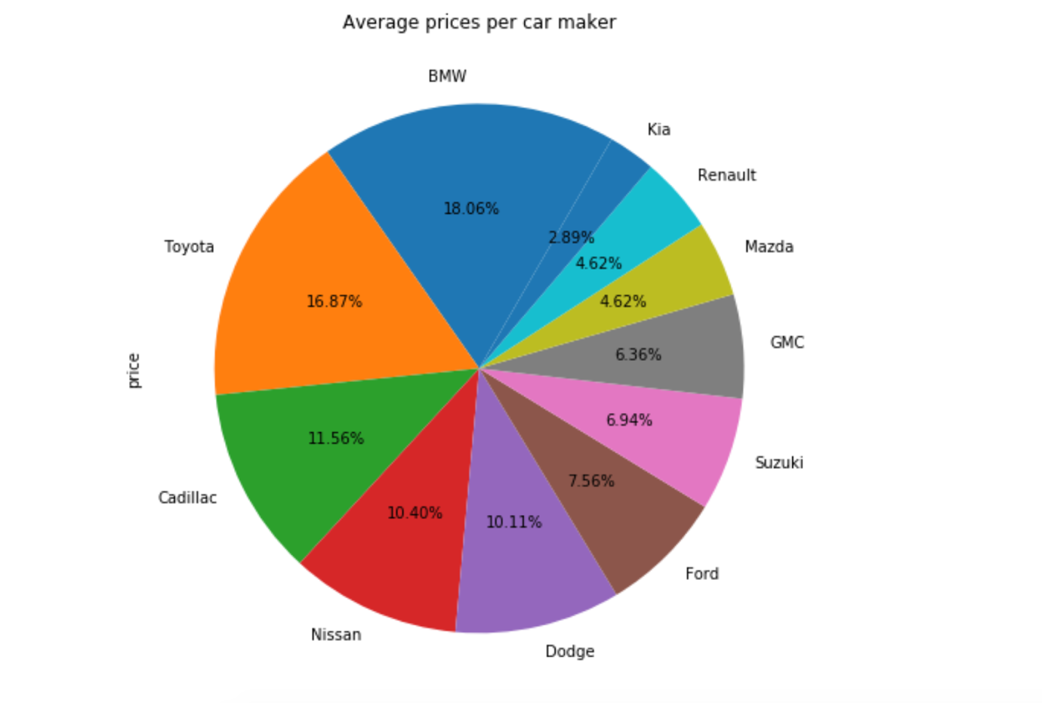

The above pie chart shows now clearly that the popularity of Toyota for Riyadh residents is not due to its price, in fact, the average price for Toyota the second most expensive among other car brands. That got me curious about the reason behind it, and I have searched to come across an interview for Mr. Takayuki Yoshitsugu, chief representative of Toyota Motor Corporation in the Middle East and North Africa. To quote his response on the poplarity and why Toyta own 35% of the market share in Kingdom of Saudi Arabia;

“Toyota is always working to provide ever better cars which exhibit the enduring attributes of performance, design, quality, durability and reliability that Toyota has become synonymous for. “

Hence, Riyadh residents’ loyalty secret to Toyota is due to their long trust they have for their cars.

Moving on to my next question:

**Question 3:** If the car bought used, what is the average kilometers that the car has been driven?

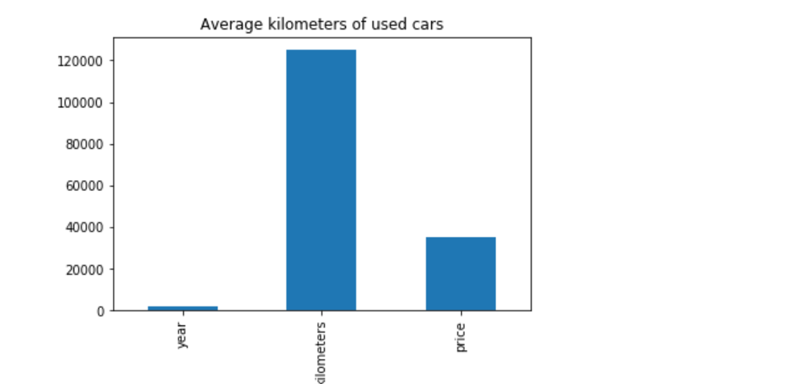

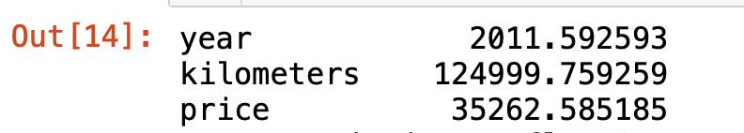

The above Bar Chart shows that used cars were bought for an average of 125,000 Kilometers driven. Also, used cars were bought for the year model of 2011. I have made a little search on the factors of buying used cars, I have found an article in [Wheels.ca](https://www.wheels.ca/about-us/) which is a website for the latest car reviews and guides. The author of the article suggesting as a rule of a thumb, the average kilometers passed per year can be 20,000 kilometers. Doing a little bit of a math here, from 2011 till 2019 the average car would be gone 160,000 kilometers overall. So, the 125,000 kilometers that we have found makes a lot of sense.

**To conclude:**

Riyadh residents have great loyalty and trust for Toyota, despite its expensive price. Also, the market for used cars in Riyadh is quite big, and cars that were driven for an average of 125,000 Kilometers were bought the most.

**Data Source:**

<https://www.kaggle.com/energykingdom/saudi-arabia-car-prices-machine-learning>

**References:**

<https://en.wikipedia.org/wiki/Riyadh>

<https://www.arabnews.com/motoring/news/897836>

<https://www.wheels.ca/top-ten/10-questions-to-ask-if-buying-a-used-car-from-a-private-seller/>